**Experiment 1:**

T Raja Aadhithan

602162021

**Study of Unix general purpose utility command:**

**man command:** Displays help of the following command keyword.

i/p:



o/p:

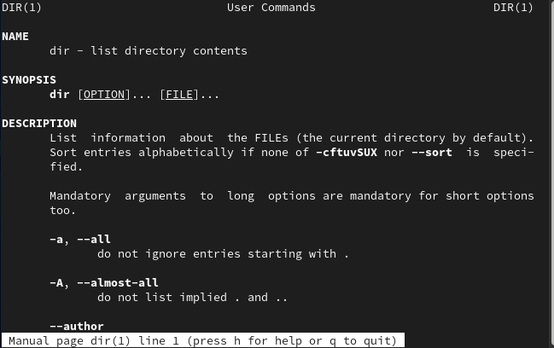

**who command:** Displays the current users of the system.



**cat command:** Displays the content of the file in the shell terminal.

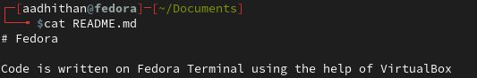

**cd command:** Navigates across directories:

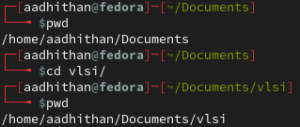

**ps command:** Lists the current working processes

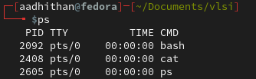

**ls command:** lists the content of the directory

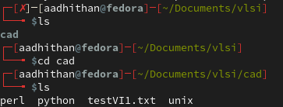

**cp command:** copies the file

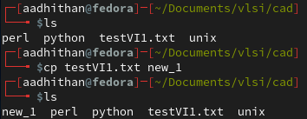

**mv command:** moves the file to new destination

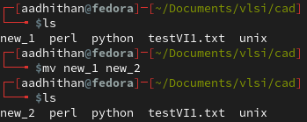

**rm command:** removes/deletes the file

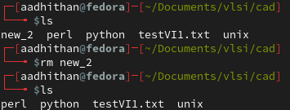

**mkdir command:** creates a new directory

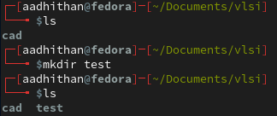

**rmdir command:** deletes an existing directory

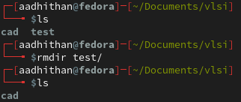

**echo command:** prints the text that follows the command



**date command:** prints the current date and time



**time command:** displays the time required to execute a command

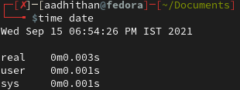

**history command:** Displays the history of commands

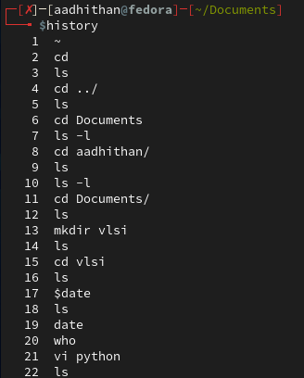

**pwd command:** prints current working directory



**shutdown command:** schedules shutdown to happen in 2 minutes



**chmod command:** used to change preferences of a file

Before changing user preferences:

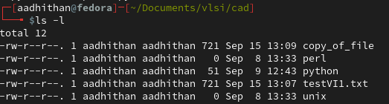

Changing preferences:

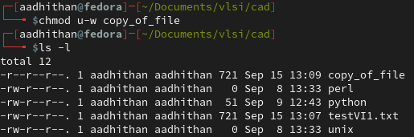

**cal command:** Displays the calendar

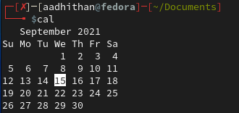

**kill command:** kills a program that’s running

**more command:** shifts the file one screen at a time

**chown command:** change owner of a file

**finger command:** gets details about a domain

**logout command:** allows to programmatically logout from the session

**To print the list of files created:**

Using tree command to display the contents in a tree and branch fashion

